Geospatial Software Development

February 14, 2017

All Roads Lead to Vegas

Elise Estep & Kyungmin Kim

TABLE OF CONTENTS

Purpose 1

Finding the Software 1

Restrictions 1

Using the Software 1

Purpose

The purpose of this software is to show the potential “optimal” routes for a new regional rail service between any two points and based on existing rails, highways, cities, lakes, streams, and slopes. The two points specifically in mind for this project were the Frontrunner Station in Provo, Utah and one of three end points in Las Vegas, Nevada.

Finding the Software

The files are located at <https://github.com/eliseestep/514AllRoadsLeadToVegas>. The geodatabase is located on Google Drive because GitHub wouldn’t accept the file size of the zipped folder. The required files are the AllRoadsTemplate.mxd, Tool_Scripts.zip, and AllRoadsDatabase.gdb (the address is written in the GDBLocation.docx file). You will also need a CoverPage.pdf, but you will likely wish to create your own. Regardless, ours is also provided on GitHub.

Restrictions

This tool was created for ArcMap 10.3 using a Python script. The tool should be compatible with other versions of ArcMap, but no guarantee.

The tool should be able to calculate least cost railroad paths between any two points, but it was developed specifically for the area between Provo, Utah and Las Vegas, Nevada.

Using the Software

After retrieving the files from GitHub and Google Drive, assemble the files together in a folder. Unzip the geodatabase and the Tool_Scripts folder, create an output folder (any name), and make sure you’ve got a cover page named CoverPage.pdf (either ours or one of your own).

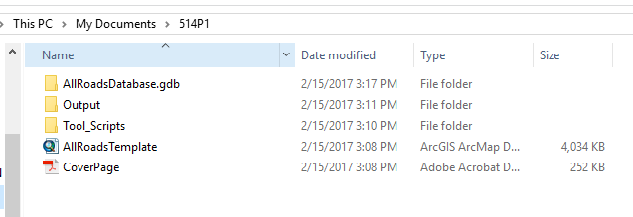

Open ArcMap. Set the default geodatabase for the map to the AllRoadsDatabase.gdb, and load the AllRoadsTemplate.mxd. You will probably need to “Browse for more…” to find the AllRoadsTemplate.mxd.

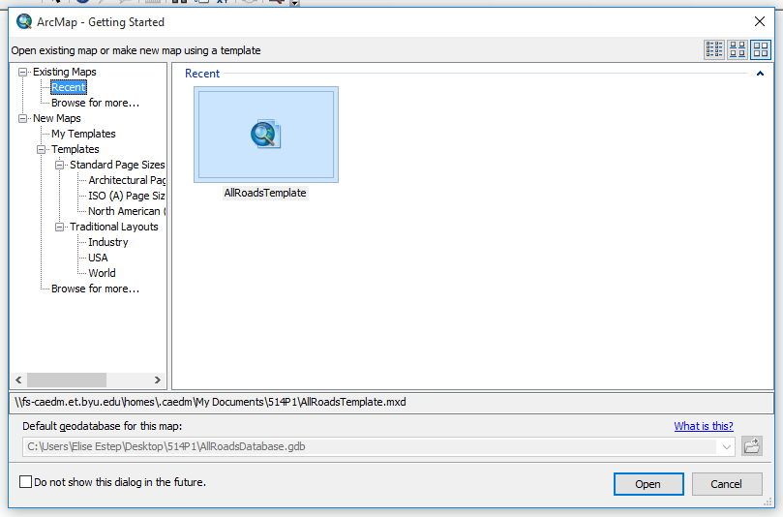

When you open the AllRoadsTemplate, the links to the ProvoFrontrunnerStation and Vegas Stations will be broken.

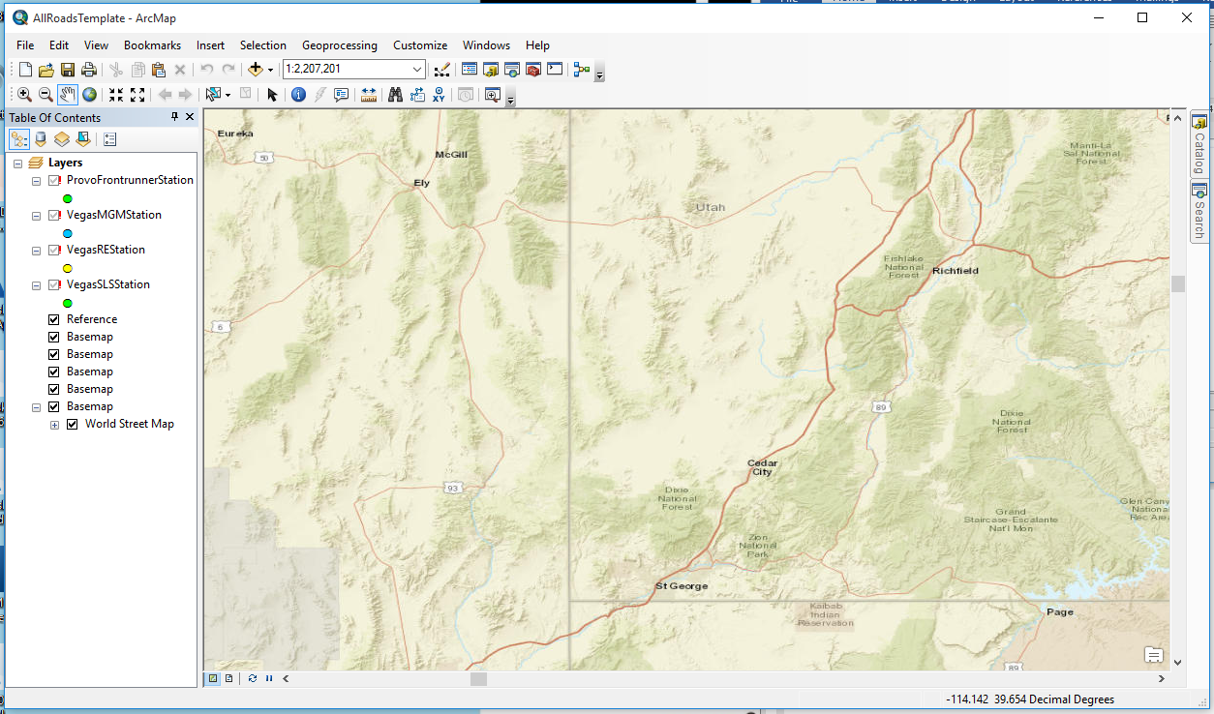

If you have your own end points, you can delete these. If you would like to use these end points, repair the link by click on one of the red exclamation points and navigating to the ProvoFrontrunnerStation feature class located within the AllRoadsDatabase. Fixing one link will fix the rest. Whatever points and classes are included in your Table of Contents will be printed to the map legend. We recommend including only the start and end points and a single basemap (extraneous base maps may be loaded in with the template and can be deleted). The least cost path will be generated for each separate map and will automatically be included in the map legend.

The AllRoads tool will be available under the Toolbox within the AllRoadsDatabase, visible under the Catalog.

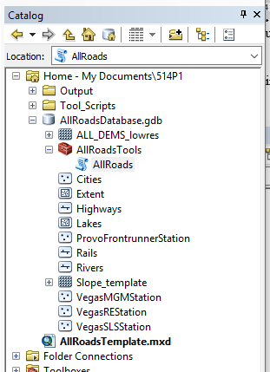

The Help file is attached below. A video walk-through of this tool is available at <https://youtu.be/FwXYwTEiz6s>.

# AllRoads

## Title  AllRoads

## Summary

This tool was built to generate a PDF atlas of multiple potential routes between two points of interest. Templates for all layer inputs are included with the downloaded files. The provided Start Point is Provo FrontRunner station, and three possible rail stations (End Points) in Las Vegas were also given. If the included templates are used, run time is approximately 25 minutes.

## Usage

This tool was built to find Least Cost Paths for potential railways between the Frontrunner Station in Provo, UT to one of three stations in Las Vegas, NV. In theory it could be applied to any two points. After running this tool, intermediate classes and rasters will be available in the geodatabase and can be pulled in to view.

## Syntax

AllRoads (Railroads, Lakes, Rivers, Highways, Cities, Slopes, Starting_Point, Ending_Point, Geodatabase, Output_Coordinate_System, Cell_Size, Template_Layer, Output_Folder, Extent_Polygon, Cover_Page_Folder)

|  |  |  |
| --- | --- | --- |
| Parameter | Explanation | Data Type |
| Railroads | Dialog Reference  There is a template feature class for the area between Provo and Las Vegas. This template is named 'Rails' and is located in AllRoadsDatabase.gdb. The code was written for only one railroad input, so if you have multiple rail lines to include they will need to be merged previous to being used for this tool.  There is no python reference for this parameter. | Feature Class |
| Lakes | Dialog Reference  There is a template feature class for the area between Provo and Las Vegas. This template is named 'Lakes' and is located in AllRoadsDatabase.gdb.  There is no python reference for this parameter. | Feature Class |
| Rivers | Dialog Reference  There is a template feature class for the area between Provo and Las Vegas. This template is named 'Rivers' and is located in AllRoadsDatabase.gdb.  There is no python reference for this parameter. | Feature Class |
| Highways | Dialog Reference  There is a template feature class for the area between Provo and Las Vegas. This template is named 'Highways' and is located in AllRoadsDatabase.gdb.  There is no python reference for this parameter. | Feature Class |
| Cities | Dialog Reference  There is a template feature class for the area between Provo and Las Vegas. This template is named 'Cities' and is located in AllRoadsDatabase.gdb.  There is no python reference for this parameter. | Feature Class |
| Slopes | Dialog Reference  There is a template feature class for the area between Provo and Las Vegas. This template is named 'Slope_template' and is located in AllRoadsDatabase.gdb. The Slope template was created from a merged DEM file, units in decimal degrees. Cell size for the Slope_template is set to 0.005 (original DEM cell size was approximately 0.0009).  There is no python reference for this parameter. | Raster Layer |
| Starting_Point | Dialog Reference  The template starting point provided in AllRoadsDatabase.gdb is ProvoFrontrunnerStation. If you wish to use a different starting point, please note that it must be the only point in that feature class.  There is no python reference for this parameter. | Feature Class |
| Ending_Point | Dialog Reference  The template ending points provided in AllRoadsDatabase.gdb are VegasMGMStation, VegasREStation, and VegasSLSSation. Only one can be used at a time for this tool. If you wish to use a different ending point, please note that it must be the only point in that feature class.  There is no python reference for this parameter. | Feature Class |
| Geodatabase | Dialog Reference  The geodatabase intended for use with this tool is the AllRoadsDatabase.  There is no python reference for this parameter. | Workspace |
| Output_Coordinate_System | Dialog Reference  The coordinate system used when developing this tool was GCS NAD 1983.  There is no python reference for this parameter. | Coordinate System |
| Cell_Size | Dialog Reference  The cell size used when developing this tool was 0.005 decimal degrees.  There is no python reference for this parameter. | Cell Size |
| Template_Layer | Dialog Reference  This is actually a broken parameter. The code currently doesn't use it, but could be adjusted to apply the symbology of some template to the layers before printing them to the PDF.  There is no python reference for this parameter. | Layer |
| Output_Folder | Dialog Reference  This is the folder to which your PDFs will print.  There is no python reference for this parameter. | Folder |
| Extent_Polygon | Dialog Reference  The template starting point provided in AllRoadsDatabase.gdb is 'Extent'. The purpose of this parameter is to mark the boundaries of your area of interest so other input classes can be trimmed to reduce run time.  There is no python reference for this parameter. | Feature Class |
| Cover_Page_Folder | Dialog Reference  The folder where your cover page is stored. The cover page will be printed in the PDF, but must be named "CoverPage.pdf". You could alter this by changing the name in the Python script associated with this tool, if you're that inconvienced by (re)naming it.  There is no python reference for this parameter. | Folder |